Минобрнауки России

Бузулукский гуманитарно-технологический институт (филиал)
федерального государственного бюджетного образовательного учреждения
высшего профессионального образования
«Оренбургский государственный университет»

Кафедра гуманитарных дисциплин

ФОНД ОЦЕНОЧНЫХ СРЕДСТВ
ПО ДИСЦИПЛИНЕ
«Б.1.В.ОД.1 Профессионально-ориентированный иностранный язык»

Уровень высшего образования
БАКАЛАВРИАТ
Направление подготовки
23.03.03 Эксплуатация транспортно-технологических машин и комплексов

Сервис транспортных и технологических машин и оборудования (нефтегазодобыча)

Тип образовательной программы
Программа академического бакалавриата

Квалификация
Бакалавр
Форма обучения
Очная
Заочная

Год набора 2016
Фонд оценочных средств предназначен для контроля знаний обучающихся по направлению подготовки 44.03.01 Эксплуатация транспортно-технологических машин и комплексов по дисциплине «Иностранный язык»(английский)

Фонд оценочных средств обсужден на заседании кафедры гуманитарных дисциплин

протокол № ________от "___" __________ 20__г.
Е.В. Фролова
Первый заместитель директора по УР _________________________________Н.В. Хомякова_________________________________
подпись расшифровка подписи
Исполнители:
Доцент кафедры педагогического образования к.п.н Е.Н. Чернышова
___________________________________________________________
должность подпись расшифровка подписи

должность подпись расшифровка подписи

Раздел 1. Перечень компетенций, с указанием этапов их формирования в процессе освоения дисциплины
Формируемые компетенции | Планируемые результаты обучения по дисциплине, характеризующие этапы формирования компетенций | Виды оценочных средств по уровню сложности/шифр раздела в данном документе
ПК-18 способность к анализу передового научно-технического опыта и тенденций развития технологий эксплуатации транспортных и транспортно-технологических машин и оборудования | Знать:  - лексический и грамматический материал для понимания и анализа текстов по профилю. | Блок А − задания репродуктивного уровня:  Тестовые вопросы  Вопросы для опроса
 | Уметь:  - извлекать необходимую информацию из различного вида текстов (текстов по широкому и узкому профилю направления). | Блок В − задания реконструктивного уровня:  устное индивидуальное собеседование – сообщение по УРС (учебно-речевая ситуация)
 | Владеть:  - навыками получения необходимой информации, находящейся в открытом доступе (из специализированного журнала, рекламы, сайта в Интернете и т.д.). | Блок С  задания практико-ориентированного или исследовательского уровня:  выполнение творческого задания

Раздел 2. Типовые контрольные задания и иные материалы, необходимые для оценки планируемых результатов обучения по дисциплине (оценочные средства). Описание показателей и критериев оценивания компетенций, описание шкал оценивания
Блок А

А.0 Фонд тестовых заданий по дисциплине, разработанный и утвержденный в соответствии с Положением.

Раздел 1 Аautomobile s parts

Task 1 Match the word with its Russian equivalent:

1.1 power plant a) силовая установка;
1.2 power train b) ходовая часть;
1.3 running gear c) силовая передача.
2
1.3 brake a) двигатель;
1.4 clutch b) тормоз;
1.5 engine c) сцепление.
3
1.6 chassis a) шасси;
1.7 body b) капот;
1 .8 hood c) кузов.
4
1.9 steering wheel a) стеклоочиститель;
1.10 lubricating b) смазка;
1.12 windshield wiper c) рулевое колесо.

Task 2 Choose English terms below to match the following automobile parts:
1.2.1) the engine 1.2. 2) the chassis 1.2. 3) the body

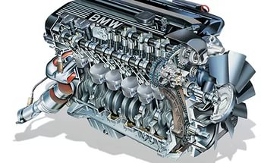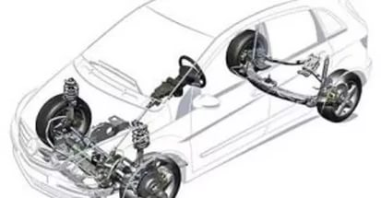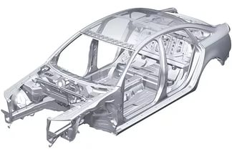

a) fuel system; d) running gear; g) heater;
b) accessories; e) lubricating system; h) windshield wipers;
c) cooling system; f) steering system; I) electric system.

Task 3 Choose the wright answer
1.3.1 The automobile is made up of … basic parts
a) one; b) two; c) three.
2 Most automobile engines have … cylinders
a) five; b) six; c) seven.
1.3.2 Most automobile engines work on … - stroke cycle
a) three; b) four; c) five.

Task 1.4 .1 Finish sentences in the first column using corresponding endings in the second column
1. Тhe automobile is made up of ... | a) a power transmission, running gear, steering and braking systems.
2. The power plant is... | b) the clutch, gear box, propeller shafts, final drive, differential and axle shafts
3. The engine includes ... | c) a hood, fenders and accessories
4. The chassis consists of ... | d) the engine, the chassis and the body
5. The power transmission contains ... | e) a frame with axles, wheels and springs
6. The running gear consists of ... | f) the source of power
7. The body has ... | g) fuel, cooling, electric and lubricating systems

Task.1. 5 Match the following mechanisms with their descriptions
1.5.1. Mechanism, which is used to stop the car
a) Clutch;
b) Brakes;
c) Gearbox;
d) Steering system.

1.5.2. Mechanism, which is used to guide the car
a) Clutch;
b) Brakes;
c) Gearbox;
d) Steering system.
1.5.3. Mechanism, which engages or disengages the engine and the car wheels
a) Clutch;
b) Brakes;
c) Gearbox;
d) Steering system.

1.5.4 Mechanism, which is used to change the speed of the car
a) Clutch;
b) Windshield wiper
c) Gearbox;
d) Brakes.
1.5.5 Device, which is designed to measure the speed of the car
a) Heater;
b) Windscreen;
c) Kilometer;
d) Speedometer.

Task 1. 6 Choose the wright answer
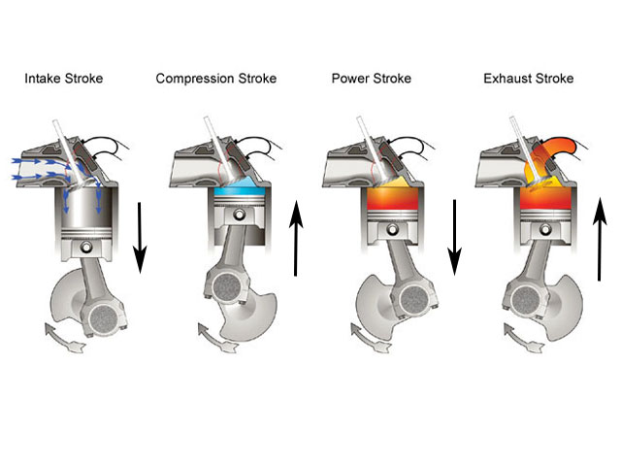
1.6.1During ….. the intake valve opens and a charge of fuel mixture flows into the cylinder.
a) the power stroke; b) the exhaust stroke;
c) the inlet stroke; d) the compression stroke.
    - During ….. the inlet valve is closed and the fuel is compressed by the rising piston.
a) the power stroke; b) the exhaust stroke;
c) the inlet stroke; d) the compression stroke.

1.6.3. During ….. both valves are closed, pressure rises in the combustion chamber, and the spark ignites the mixture.
a) the power stroke; b) the exhaust stroke;
c) the inlet stroke; d) the compression stroke.

1.6.4. During ….. the exhaust valve is opened, pressure is released and residual gases into the atmosphere through the exhaust valve.
a) the power stroke; b) the exhaust stroke;
c) the inlet stroke; d) the compression stroke.

Task 1.7 Complete the following sentences, choosing the correct version
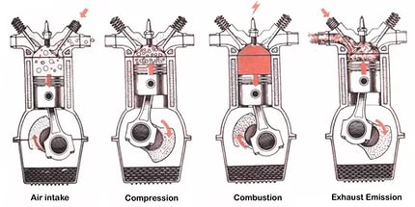
1.7.1. The internal combustion engine is called so because fuel is burned...
a) outside the engine;
b) inside the engine.

1.7.2. On the inlet stroke …
a) the intake valve opens;
b) the intake valve is closed;
c) the intake and the exhaust valves are closed.

1.7.3. On the compression stroke …
a) the intake valve opens;
b) the intake valve is closed;
c) the intake and the exhaust valves are closed.

1.7.4. On the power stroke …
a) the intake valve opens;
b) the intake valve is closed;
c) the intake and the exhaust valves are closed.

1.7.5. On the exhaust stroke …
a) the exhaust valve opens;
b) the intake valve is closed;
c) the intake and the exhaust valves are closed.

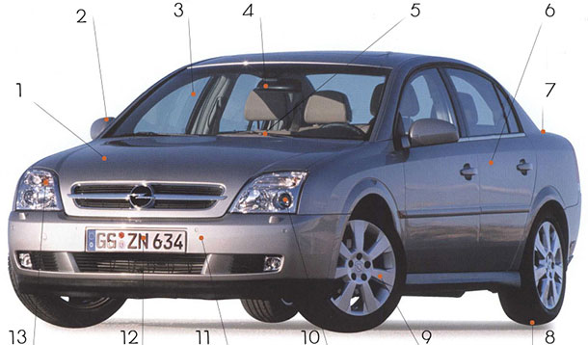

1.7.6. Дайте перевод слов в соответствие с изображением

- Bonnet /ˈbɒnɪt/ –
- Wing mirror /wɪŋ ˈmɪrə(r)/ –.
- Windscreen /ˈwɪn(d)ˌskriːn/ –.
- Rear-view mirror /rɪˈvjuː ˈmɪrə(r)/ –.
- Windscreen wiper /ˈwɪn(d)ˌskriːn ˈwaɪpə(r)/ –.
- Door –.
- Boot /buːt/ –
- Tyre или tire /ˈtaɪə(r)/ –.
- Wheel /wiːl/ –.
- Headlight /ˈhedˌlaɪt/ –.
- Bumper /ˈbʌmpə(r)/ –.
- Licence (или license) plate /ˈlaɪs(ə)ns pleɪt/ –.
- Indicator /ˈɪndɪˌkeɪtə(r)/ –

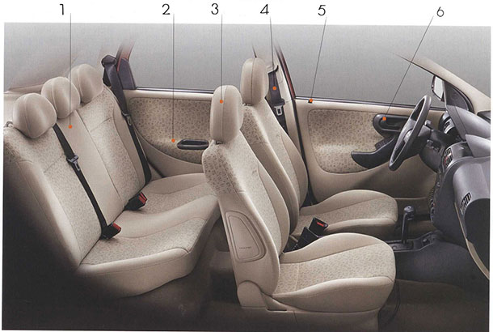
1.7.7. Дайте перевод слов в соответствие с изображением
- Back seat –.
- Armrest – .
- Headrest –
- Seatbelt – .
- Door lock – .
- Door handle –

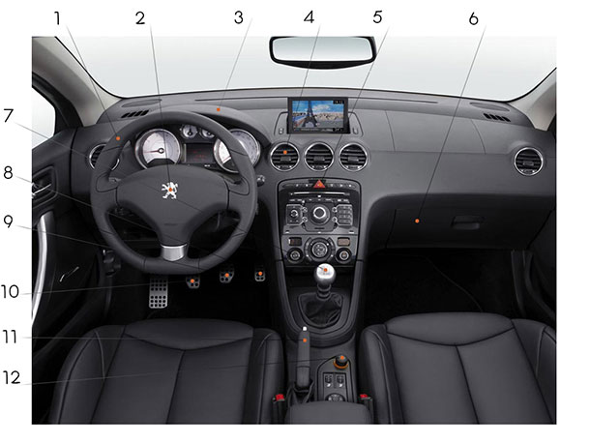
1.7.8. Найди ошибки
1. Steering wheel /ˈstɪərɪŋ/ – сигнал, клаксон
2. Horn /hɔː(r)n/ – прикуриватель
3. Dashboard – приборная панель.
4. Air vent – вентиляция.
5. Hazard light switch /ˈhæzə(r)d/ – кнопка аварийной сигнализации.
6. Glove compartment – бардачок.
7. Gear shift – рычаг переключения передач.
8 Accelerator – педаль газа.
9. Brake – педаль тормоза.
10. Handbrake – стояночный тормоз.
11. Cigarette lighter – рулевое колесо.

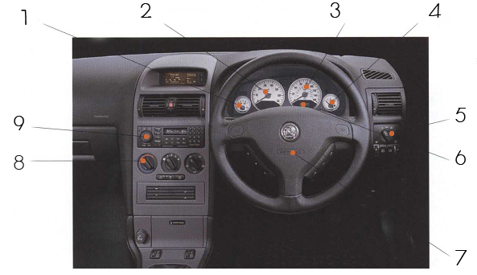
1.7.9. Соотнесите перевод слов
- Car stereo – автомобильный приемник, автомагнитола.
- Air bag – подушка безопасности.
- Heater controls – управление обогревом.
- Lights switch – переключатель света.
- Fuel gauge – указатель уровня топлива.
- Odometer – одометр (отображает пробег автомобиля).
- Rev counter / tachometer – тахометр (отображает количество оборотов двигателя в минуту).
- Speedometer – спидометр.
- Temperature gauge /ɡeɪdʒ/ – датчик температуры двигателя.

Раздел №2 Assembling a car

Choose the correct variant:
2.1. Сначала ржавые части автомобиля привозят на завод.
a. First, the rusty machine parts are being brought into the factory.
b. First, the rusty machine parts are brought into the factory.
c. First, they brought the rusty machine parts into the factory.
2.2 Солнечная панель – это устройство, которое преобразует
солнечный свет в электричество.
a. A solar panel is a device which converts sunshine into electricity.
b. A sun panel is a device which converts sunlight into electricity.
c. A solar panel is a device which converts sunlight into electricity.
2.3. Топливные баки, расположенные под задним сиденьем, заполняются водородом.
a. The fuel tanks, placed under the rear seat, are filled with hydrogen.
b. The oil tanks, placed under the back seat, are full of hydrogen.
c. The tanks with fuel under the rear seat are being filled with hydrogen.
2.4. Когда свеча зажигания воспламеняется, газы взрываются.
a. When spark plug sets on fire the gas explode.
b. The spark plug ignited when the gases exploded.
c. When the spark plug ignites, the gases explode.
2.5. Это устройство преобразовало сигналы высокой частоты в
низкочастотные.
a. These signals are converted by this device from high frequency to
low frequency.
b. This device converted high frequency signals to low frequency.
c. This device converts high frequency signals to the low ones.
2.6. Барометр – это прибор, который измеряет давление.
a. Barometer is a device measuring pressure.
b. Barometer is a device to measure pressure.
c. Barometer is a device that measures pressure.
2.7 Вы заводите мотор нажатием этой кнопки.
a. You start the motor by pressing this button.
b. You start the motor to press this button.
c. You start the motor with pressing this button.
2.8. Вращаясь, коленвал приводит в действие поршень.
a. Rotating the crankshaft it drives the piston up.
b. As the crankshaft rotates, it drives the piston up.
c. While the crankshaft is rotating, it is driving the piston up.
2.9. Поставь машину в гараж и выключи двигатель.
a. Drive the car into the garage and turn over the engine.
b. Drive the car into the garage and turn out the engine.
c. Drive the car into the garage and turn off the engine.
2.10. Пассажир включает кассу-автомат, касаясь экрана.
a. The passenger activates the ticket machine by touching the screen.
b. The passenger activates the ticket machine when touches the screen.
c. The passenger activates the ticket machine as touching the screen.
2.11. Долото предназначено для срезания слоев древесины.
a. Chisels are for cutting out pieces of wood.
b. Chisels cut out pieces of wood.
c. Chisels is used for cutting wood.
2.12. Карбюратор создан для смешивания топлива с воздухом.
a. Carburetors mix fuel with air.
b. Carburetors are designed for mixing fuel with air.
c. Carburetors is used as a mixer for fuel and air.
2.13. Элеваторы были покрыты огнеупорным материалом для их
защиты.
a. Elevators were protected by fire-resistant material.
b. Elevators were covered by fire-resistant material to protect them.
c. Elevators were covered with fire-resistant material to protect them.
2.14. Выбросы углерода в городе сократились более чем на 50%.
a. Carbon emission in the city has gone down by over 50%.
b. Carbon emission in the city decreased down by over 50%.
c. Carbon emission in the city went down over 50%.
2.15. При сжатии газ конденсируется, выделяя тепло.
a. Compressed gas condenses, and gives out the heat.
b. When a gas is compressed, it condenses giving out the heat.
c. When a gas is compressed it gives out heat.
1. Долото предназначено для срезания слоев древесины.
a. Chisels are for cutting out pieces of wood.
b. Chisels cut out pieces of wood.
c. Chisels is used for cutting wood.
2.16. Карбюратор создан для смешивания топлива с воздухом.
a. Carburetors mix fuel with air.
b. Carburetors are designed for mixing fuel with air.
c. Carburetors is used as a mixer for fuel and air.
2.17.. Элеваторы были покрыты огнеупорным материалом для их
защиты.
a. Elevators were protected by fire-resistant material.
b. Elevators were covered by fire-resistant material to protect them.
c. Elevators were covered with fire-resistant material to protect them.
4. Выбросы углерода в городе сократились более чем на 50%.
a. Carbon emission in the city has gone down by over 50%.
b. Carbon emission in the city decreased down by over 50%.
c. Carbon emission in the city went down over 50%.
2.18. При сжатии газ конденсируется, выделяя тепло.
a. Compressed gas condenses, and gives out the heat.
b. When a gas is compressed, it condenses giving out the heat.
c. When a gas is compressed it gives out heat.

2.19. Найдите вторую часть словосочетания: windscreen...
a) bumper b) wipers c) pipe d) plate
2.20. Найдите вторую часть словосочетания: exhaust...
a) bumper b) wipers c) pipe d) plate
2.21. Найдите вторую часть словосочетания: front...
a) bumper b) wipers c) pipe d) plate
2.23. Найдите вторую часть словосочетания: number...
a) bumper b) wipers c) pipe d) plate
2.24. Найдите вторую часть словосочетания: wheel...
a) bumper b) wipers c) trim d) plate
2.25. Найдите вторую часть словосочетания: petrol...
a) cap b) wipers c) pipe d) plate

Раздел 2. Assembling a Car
2.1. Tell him not to forget …. ticket.
a) My b) our c) Her d) his
2.2. I see that he has lost … keys.
a) Themselves b) ourselves c) His d) me
2.3. I will ask him … .
a) Myself b) herself c) Ourselves d) yourself
2.4. That is his manager, …name is Jane.
a) Her b) his c) Us d) our
2.5. … will help me?
a) Who b) when c) Why d) how
2.6. Do you know the man … wrote the 8-DReport?
a) Who b) which c) Why d) how
2.7. Who’s there? It’s …
- Me b) you c) I d) her
2.8. The magazine … you lent me is very interesting.
a) That b) this c) Those d) these
2.9. … is a new Peugeot.
a) When b) why c)This d) where
2.10. My brother is a professional. …repairs a lot of cars.
a) she b) he c) I d) him
2.11. I don’t like this motorbike of ..... .
a) your b) yours c) you d) Am
2.12. Willy is wearing a uniform that isn’t ..... .
a) He b) him c) his d) ours
2.13. My auto is bigger than hers, but .....is nicer.
a) Her b) hers c) his d) him
2.14. We know their names, but they don’t know ..... .
a) Our b) ours c) us d) his
2.15. Remember .....to your headmaster.
a) Mine b) Me c) My d) She
2.16. This is not my cup; .....is big.
a) Mine b) My c) Me d) his
2.17. Mary and Jim visit .....colleagues very often.
a) They b) Their c) Theirs d) Mine
2.18. We protect___from the cold with warm things.
a) herself b) ourselves c) itself d) yourself
2.19. He cut____shaving this morning.
a) himself b) themselves c) myself d) yourself
2.20.Please, put the book … the table.
- In c) on
- Into d) at
2.21. We went … the park yesterday.
- To c) in
- At d) into
2.22. Put your name … the top of the page.
- At c) to
- On d) in
2.23. The island was inhabitant, there was nobody … it.
- On c) at
- In d) into
2.24. Put some sugar … my cup, please!
- In c) into
- On d) to
2.25. There is a plate … my table, but there is no soup … it.
- into; at c) at; into
- - ; into d) On; in
2.26. Turn right … the end of the street.
- to c) in
- at d) into
2.27. ‘ Where is my bag?’ ‘ It’s … the boot’
- In c) at
- - d) into
2.28. Where are you going… your holidays?
- At c) on
- To d) for
2.29. My cat likes to sit … the window.
- At c) in
- Near d) on
2.30. I always leave my car ... the underground parking.
a) on b) in c) over d) between
2.31. My sister … a student.
- not c) are
- Am d) Is
2.32. Your brother is a scientist, … he?
- Isn’t c) aren’t
- Is d) am
2.33. This bag … heavy.
- am c) is
- Are d) were
2.34. … there any books on the table?
- Am c) is
- Are d) isn’t
2.35. Once upon a time there … a boy, who lived in the forest.
- Is c) am
- Was d) were
2.36. What color … your car?
- Is c) are
- Does d) –
2.37. How old … you when it happened?
- Were c) was
- Is d) are
2.38. When I arrived she … sleeping at the living room.
- Were c) was
- Is d) are
2.39. Why … you looking like that?
- Am c) were
- Is d) are
2.40. The man ___ to work every day. He ___ a bus to get there.
a) goes, takes b) go, take
c) goes, take d) go, takes
2.41. She always___ lunch at college.
a) have b) has
c) haves d) hav
2.42. Richard's life in Paris is a bit difficult. He ___ only English.
a) speak b) speaks
c) speaking d) spoke
2.43. What's the matter? You __ very sad.
a) looks b) looking
c) look d) looked
2.44. The building of the trade centre (begin) a month ago.
a) begins b) begined
c) began d) begin
2.45. It (be) slippery yesterday. I (change) the tires of my car.
a) is, change b) was, changing
c) was, changed d) is, changed
2.46. The postman (bring) the morning mail only at 10 o'clock.
a) brings b) bring
c) bringed d) brought
2.47. Tomorrow it _____ cold and wet.
a) are b) will be
c) is d) was
2.48. He___ fifty in June.
a) is b) are
c) will be d) were
2.49. It's too dark to go. I ___ a taxi.
a) will call b) calls
c) wills call d) calling
2.50. He studied sculpture because he enjoyed ___ with clay.
a) to work b) working
c) haveworked d) to be working
2.51. We went ___ last holiday.
a) to climb b) climbing
c) for climbing d) to climbing
2.52. Who ___ Phil with his homework?
a) does help b) helps
c) do help d) has help
2.53. Fiona never buys expensive clothes, ___ ?
a) does Fiona b) doesn’t she
c) does she d) don’t she
2.54. People ___ their lives worrying about money.
a) are spending b) spend
c) have spent d) has spent
2.55. Jill ___ long brown hair and big blue eyes.
a) is having b) has got
c) have got d) are having
2.56. I ___ what you’re talking about.
a) don’t understand b) am not understanding
c) not understanding d) are not understand
2.57. In his youth, he ___ very lazy.
a) was being b) have been
c) was d) were
2.58. How many people ___ in The Second World War?
a) did die b) has died
c) died d) had died
2.59. How long ago ___ ?
a) did they marry b) has they married
c) they married d) married they
2.60. Lose an hour in the morning, and you __ all day looking for it.
a) have spent b) spending
c) were spending d) will spend
2.61. Students think that in a short time the reform ___ education move useful.
a) will have made b) make
c) will make d) has made
2.62. It usually … me 40 minutes to get to the college.
a) took b) takes c) taking d) taken
2.63. My working day … at 8 o’clock every day.
a) starts b) started c) will start d) have started
2.64. Sometimes my father and I … chess.
a) played b) will play c) play d) playing
2.65. Two years ago my brother … school and … Moscow State University.
a)finish, enter b) finishes, enters
c) finishing, entering d) finished, entered
2.66. He … the book with pleasure and … it to me yesterday.
a) read, returned b) read, return
c) reading, returning d) reads, returns
2.67. We … a lot last year.
a) travel b) will travel c) travelled d) traveling
2.68. In 1571 Moscow ... its capital status to St.Petersburg.
a) lost b) loose c) will lose d) losen
2.69. The seller … the goods to the customer in a day.
a) sent b) will send c) send d) sending
2.70. We … this documentary with great interest next week.
a)watched b) will watch c) watch d) watching
2.71. They … the farm in July next year.
a) visit b) visited c) will visit d) visiting
2.72. Their guests ... lunch after the walk tomorrow.
a) had b) will have c) have had d) having
2.73. Russia ... political weight in the past and ... it in future.
a) had, will have b) had, have c) having, has d) had, had
2.74. Russia's economy ... on oil prices.
a) depended b) depends c) have depended d) had depended
2.75. Election of the President ....place every four years.
a) took b) takes c) taking d) taken
2.76. Moscow ... its 850 Anniversary in 1997.
a) celebrate b) celebrated c) will celebrate d) celebrating
2.77. On 12th March, 1918 the City of Moscow ... the capital of Soviet Russia.
a) became b) becoming c) becomes d) had become
2.78. Steve ... shopping very seldom.
a) gone b) going c) goes d) go
2.79. We are going to change left ___.
a) chairs b) tyre c) flowers d) flash cards
2.80. The _____ is ideal for small parking spaces.
a) SUV b) coupe c) limousine d) sedan
2.81. The Englishmen drive on the ___.
a) left b) right c) center d) ice
2.82. You can see a lot of cool ___ in London, Bentley is one of them.
a) homes b) cars c) gardens d) towers
2.83. You open the ____ to look at the engine.
a) bonnet b) antenna c) door d) petrol cap
2.84. The true identification of any auto is the____.
a) antenna b) logo c) window d) mirror
2.85. You put the suitcases in the __________,
a) boot b) antenna c) door d) petrol cap
2.86. Using chemicals, petrol or diesel you should be very careful to avoid ____ .
a) injury b) crack c) lack d) poisoning
2.87. The Mercedes star is a well-known _____.
a) antenna b) logo c) window d) mirror
2.88. Open the ____________and let some sun and fresh air into the car.
a) antenna b) logo c) sunroof d) mirror
2.89.When it starts raining, you need to switch on the ________.
a) windscreen wipers b) logo c) sunroof d) mirror
2.90. Use a ______ to raise the vehicle.
a) windscreen wipers b) logo c) sunroof d) jack
2.91. 'What model is that?' 'I don't know, I can't see the ________from here.'
a) windscreen wipers b) logo c) sunroof d) mirror
2.92. The most famous brand made in Russia is _____.
a) Lada b) BMW c) Reno d) Suzuki
2.93. The money you pay when you buy a car is called _____.
a) price b) size c) sunroof d) mirror
2.94. The money you get when you sell a car is called _____.
a) mirror b) size c) sunroof d) resale value
2.95. How much petrol or diesel the car uses? The factor is called _____.
a) mirror b) fuel consumption c) sunroof d) resale value
2.96. When customers always buy their cars from the same manufacturer is called _____.
a) mirror b) brand loyalty c) sunroof d) resale value
2.97. I live in the country and there is no public _______.
a) mirror b) brand loyalty c) transport d) resale value
2.98. KAMAZ has a _______ engine.
a) diesel b) oil c) sunroof d) resale value
2.99. The manufacturers always do _____ tests.
a) mirror b) crash c) sunroof d) resale value
2.100.Anti Blocking System is ______ .
a) the ABC b) IBS c) ABS d) AVS

Раздел-3 The New Fuel Car
3.1. The _____ is ideal for small parking spaces.
a) SUV b) coupe c) limousine d) sedan
3.2. The Englishmen drive on the ___.
a) left b) right c) center d) ice
3.3. You can see a lot of cool ___ in London, Bentley is one of them.
a) homes b) cars c) gardens d) towers
3.4. You open the ____ to look at the engine.
a) bonnet b) antenna c) door d) petrol cap
3.5. The true identification of any auto is the____.
a) antenna b) logo c) window d) mirror
3.6. You put the suitcases in the __________,
a) boot b) antenna c) door d) petrol cap
3.7. Using chemicals, petrol or diesel you should be very careful to avoid ____ .
a) injury b) crack c) lack d) poisoning
3.8. The Mercedes star is a well-known _____.
a) antenna b) logo c) window d) mirror
3.9. Open the ____________and let some sun and fresh air into the car.
a) antenna b) logo c) sunroof d) mirror
3.10.When it starts raining, you need to switch on the ________.
a) windscreen wipers b) logo c) sunroof d) mirror
3.11. Use a ______ to raise the vehicle.
a) windscreen wipers b) logo c) sunroof d) jack
3.12. 'What model is that?' 'I don't know, I can't see the ________from here.'
a) windscreen wipers b) logo c) sunroof d) mirror
3.13. The most famous brand made in Russia is _____.
a) Lada b) BMW c) Reno d) Suzuki
3.14. The money you pay when you buy a car is called _____.
a) price b) size c) sunroof d) mirror
3.15. The money you get when you sell a car is called _____.
a) mirror b) size c) sunroof d) resale value
3.16. How much petrol or diesel the car uses? The factor is called _____.
a) mirror b) fuel consumption c) sunroof d) resale value
3.17. When customers always buy their cars from the same manufacturer is called _____.
a) mirror b) brand loyalty c) sunroof d) resale value
3.18. I live in the country and there is no public _______.
a) mirror b) brand loyalty c) transport d) resale value
3.19. KAMAZ has a _______ engine.
a) diesel b) oil c) sunroof d) resale value
3.20. The manufacturers always do _____ tests.
a) mirror b) crash c) sunroof d) resale value
3.21.Anti Blocking System is ______ .
a) the ABC b) IBS c) ABS d) AVS
3.22. Найдите английские эквиваленты: сцепление
a) clutch b) engine c) gearbox d) piston
3.23. Найдите английские эквиваленты: мотор
a) clutch b) engine c) gearbox d) piston
3.24. Найдите английские эквиваленты: коробка передач
a) clutch b) engine c) gearbox d) piston
3.25. Найдите английские эквиваленты: поршень
a) clutch b) engine c) gearbox d) piston
3.26. Найдите английские эквиваленты: карданный вал
a) clutch b) propeller shaft c) spark plug d) front-wheel drive
3.27. Найдите английские эквиваленты: передний привод
a) clutch b) propeller shaft c) spark plug d) front-wheel drive
3.28. Найдите английские эквиваленты: свеча зажигания
a) clutch b) propeller shaft c) spark plug d) front-wheel drive
3.29. Найдите английские эквиваленты: V-образный двигатель
a) V-engine b) Horizontally opposed engine c) In-line engine
3.30. Найдите английские эквиваленты: двигатель с горизонтальными противолежащими цилиндрами
a) V-engine b) Horizontally opposed engine c) In-line engine
3.31. Найдите английские эквиваленты: однорядный двигатель
a) V-engine b) Horizontally opposed engine c) In-line engine
3.32. Внешняя часть автомобиля
a) bonnet b) horn c) seat belt d) dashboard
3.33. Внешняя часть автомобиля
a) ashtray b) sun roof c) seat belt d) dashboard
3.34. Внешняя часть автомобиля
a) air bag b) horn c) seat belt d) bumper
3.35. Внутренняя часть автомобиля
a) boot b) bonnet c) seat belt d) bumper
3.36. Внутренняя часть автомобиля
a) brake pedal b) bonnet c) number plate d) bumper
3.37. Внутренняя часть автомобиля
a) tire b) gearstick c) number plate d) bumper
3.38.This layout is used for high-performance engines with a compact layout such as in the BMW 7-series. The cylinders are arranged in two banks set at an angle to one another. This layout is normally more cuboid in shape than the other two.
a) V-engine b) Horizontally opposed engine c) In-line engine
3.39.This layout is wide and flat and gives the engine a low centre of gravity. The cylinders are arranged in two banks on opposite sides of the engine. It is very practical for cars with the engine located at the rear, such as the Porsche.
a) V-engine b) Horizontally opposed engine c) In-line engine
3.40. This layout is long and narrow. The cylinders are all next to each other In a single bank. It is a standard, simple layout used in the Mercedes A-class, for example.
a) V-engine b) Horizontally opposed engine c) In-line engine
3.41. The Pan-American Highway is (long) road in the world.
a) the most long b) more longer
c) the longest d) longer
3.42. the last model
a) predecessor b) prototypes c) successor d) pre-series car
3.43. limited number of handmade cars with the necessary equipment and technology inside
a) predecessor b) prototypes c) successor d) pre-series car
3.44. the next model
a) predecessor b) prototypes c) successor d) pre-series car
3.45. a limited number of cars built on an assembly line to test tooling and parts
a) predecessor b) prototypes c) successor d) pre-series car
3.46. a variation of the basic model
a) predecessor b) derivative c) successor d) pre-series car
3.47. the stage where no more design changes are possible
a) predecessor b) derivative c) design freeze d) pre-series car
3.48. a car built to show people what the future car will look like (it may have no technology inside)
a) concept car b) derivative c) design freeze d) predecessor
3.49. You put your foot on this pedal when you change gears.
a) gas pedal b) brake pedal c) clutch pedal d) predecessor
3.50. This pedal makes the car go faster.
a) gas pedal b) brake pedal c) clutch pedal d) predecessor
3.51. You fill this with petrol.
a) gas pedal b) brake pedal c) clutch pedal d) tank

Раздел-№ 4 The history of tools
4.1. It's so practical to have a near the steering wheel. I can take a drink
whenever I want.
a) cup holder b) gearstick c) sun visor d) steering wheel
4.2. In a car with manual transmission, you need to press the when you want to
change gear.
a) cup holder b) gearstick c) sun visor d) steering wheel

4.3.a) cup holder b) glove compartment c) sun visor d) steering wheel

4.4. I don't need a as I don't smoke and I don't want anyone to smoke
in my car.
a) cup holder b) glove compartment c) ashtray d) steering wheel
4.5. Could you close the _________ ? I'm getting a draught.
a) cup holder b) gearstick c) sun visor d) air vent
4.6. Which instrument shows you how fast the car is travelling?
a) speedometer b) engine oil temperature gauge c) indicator lights d) rev counter

4.7. Which instrument warns you if the engine lubrication system gets too hot?
a) speedometer b) engine oil temperature gauge c) indicator lights d) rev counter

4.8. Which instrument shows that you are indicating to turn left or right?
a) speedometer b) engine oil temperature gauge c) indicator lights d) rev counter

4.9. Which instrument shows you how often the engine is turning over?
a) speedometer b) engine oil temperature gauge c) indicator lights d) rev counter

4.10. Which instrument shows you how much petrol you have in the tank?
a) speedometer b) fuel gauge c) indicator lights d) rev counter

4.11. Which instrument indicates the voltage of the car's electrical system?
a) speedometer b) voltmeter c) indicator lights d) rev counter
4.12. Get the ….to remove those nails.
a) Claw hammer b) hand saw c) hacksaw d) Phillips screwdriver
4.13. That ….. is worn from cutting so much metal.
a) Claw hammer b) hand saw c) hacksaw d) Phillips screwdriver
4.14. A sharp …. leaves wood with a smooth edge.
a) Claw hammer b) hand saw c) hacksaw d) Phillips screwdriver
4.15. I have several heads for this ....
a) Socket wrench b) hand saw c) hacksaw d) Phillips screwdriver
4.16. Put the end of the ... completely around the bolt.
a) Claw hammer b) hand saw c) hacksaw d) box-end wrench
4.17. Are you strong enough to lift that ...?
a) Socket wrench b) hand saw c) hacksaw d) sledgehammer
4.18. An ... only grasps opposite sides of a bolt.
a) hand saw b) open-end wrench c) hacksaw d) sledgehammer
4.19. Make the opening of that ... smaller to fit the bolt.
a) adjustable wrench b) hand saw c) hacksaw d) sledgehammer

Раздел № 5 Mеtals
5.1. Wood is very often used in interiors because it looks ..... and warm.
a) natural b) light c) flammable d) elastic
5.2. Aluminium and magnesium are important for car makers because they are ..... and therefore good for weight-saving.
a) natural b) light c) flammable d) elastic
5.3. Safety regulations require that the foam used in car seats shouldn't be ......
a) natural b) light c) flammable d) elastic
5.4. Rubber should be able to withstand great temperature differences while staying ...... . In other words, it shouldn't become brittle.
a) natural b) light c) flammable d) elastic
5.5. Windscreens are made of a special ...... glass to protect drivers in accidents.
a) shatterproof b) durable c) elastic d) heat-resistant
5.6. Fabrics used in cars need to be ..... and not look old too quickly.
a) shatterproof b) durable c) elastic d) heat-resistant
5.7. Steel is used for load-bearing parts because it is .......
a) shatterproof b) elastic c) rigid d) heat-resistant
5.8. Sheet metal is used for large car parts because it is and dent-resistant.
a) shatterproof b) heat-resistant c) rigid d) malleable
5.9. Ceramic, which is ..... , is used in the catalytic converter because of the very high temperatures.
a) shatterproof b) heat-resistant c) rigid d) malleable
5.10. Aluminium is ideal for bumpers and other body parts because it is .....
a) shatterproof b) heat-resistant c) corrosion-resistant d) light
5.11. Выберите активное свойство безопасности автомобиля:
a) ABS b) airbags c) seat belt d) shatterproof windscreen
5.12. Выберите активное свойство безопасности автомобиля:
a) airbags b) xenon lights c) seat belt d) shatterproof windscreen
5.13. Выберите активное свойство безопасности автомобиля:
a) airbags b) seat belt c) adaptive cruise control d) shatterproof windscreen
5.14. Выберите активное свойство безопасности автомобиля:
a) airbags b) seat belt c) shatterproof windscreen d) automatic emergency braking
5.15. Выберите пассивное свойство безопасности автомобиля:
a) adaptive cruise control b) airbags c) automatic emergency braking d) ABS
5.16. Выберите пассивное свойство безопасности автомобиля:
a) ABS b) adaptive cruise control c) seat belt d) automatic emergency braking
5.17. Выберите пассивное свойство безопасности автомобиля:
a) ABS b) automatic emergency braking c) adaptive cruise control
d) shatterproofwindscreen
5.18. Выберите пассивное свойство безопасности автомобиля:
a) ABS b) crumple zone c) adaptive cruise control d) automatic emergency braking

Раздел 6. Есоsystem
6.1. Match the words and the phrases which have opposite meanings.
- to prohibit a) to damage
- to protect b) to clear rubbish away
- to pollute c) to be out of danger
- to throw d) to allow
- to drop litter e) to enjoy doing something
- to be in danger f) to clean
- to avoid doing something g) to catch
6. Choose the correct variant.
6.2.The smoky clouds…in the west and the red sun went down behind them.
hanged low
hung low
hang low
hang lonely
6.3. It looks like we …for treating nature so carelessly.
are been punished
have being punished
are being punished
aren’t afraid of been punished
6.4. Hot weather and smog makes me … .
to feel uncomfortable
feel uncomfortably
feel uncomfortable
feeling uncomfortable
6.5. He … me not to go against the rules of nature.
advised
was adviced
adviced
was advised
6.6. Our planet is in grave danger … human activity.
because
the reason why
for
as a result of
6.7. I … see more organizations coming together to put on and to the threat of nuclear war.
will like to
would like to
like to
would have liked to
6.8. Isaac Newton, the greatest scientist of all ages, lived in a period when the toxic effects of chemicals … less understood.
have been
had been
were
were not
6.9. And now I’d like to give the floor to Dr. Green, … is going to talk about “Environmental Protection”.
that
who
which
whose
6.10. Of all the environmental problems facing our planet today the most … is global warming, better known as the greenhouse effect.
pressed
press
pressing
pressure
6.11. Greenpeace exists to defend the environment wherever it … .
is threatened
threatened
is threatening
threatens

Выберите правильный вариант ответа согласно картинке
Задание 1.

- Airship
- Air ball
- Plane
Задание 2.
- Car-ship
- Car-boat
- Boatee
Задание 3.
- 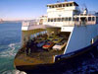
- Boat
- Lorry
- Ferry
Задание 4.
- 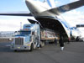
- Freight plane
- Vessel
- Air ballon
Задание 5.
- 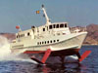
- Hydrofoil
- Truck
- Ferry
Задание 6.
- 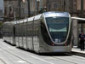
- Truck
- Light rail
- Railway wagon
Задание 7.
- 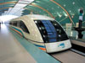
- Maglev
- Container vessel
- Houseboat
Задание 8.
- 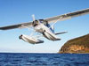
- Steamship
- Paddle steamer
- Seaplane
Задание 9.
- Speedboat
- Cruise ships
- Hovercraft
Задание 10.
- 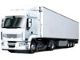
- Tram
- Segway
- Truck

Блок А1 А.1 Вопросы для опроса

Раздел№ 1 Construction Of An Automobile
1.1. Name the primary components of a car.
1.2. What does the power plant include?
1.3. How does the four cycle engine work? Describe it shortly.
1.4. What are modern carburetors fitted with?
1.5. What devices control the mixture for efficient operation under
varying conditions?
Раз Раздел 2 Assembling A Car
2.1. Name the primary components of a car.
2.2. What does the power plant include?
2.3. How does the four cycle engine work? Describe it shortly.
2.4. What are modern carburetors fitted with?
2.5. What devices control the mixture for efficient operation under
varying conditions?
Раздел-3 The New Fuel Car
3.1. What does an ecosystem include?
3.2. What are global ecosystems?
3.3. Describe each of them in short.
3.4. What does the tropical forest contain?
3.5. What causes deforestation?
3.6.What sciences is ecology based on?
3.7. How can ecology be defined as? Give your definition.
3.8 What are there the applications of the science?
3.9 What does ecosystem mean? Describe an ecosystem .
3.10 What are the decomposers? Enumerate the organisms known as decomposers.
3.11 What is the food chain? Illustrate your answer with the example.
Раздел-№4 The history of tools
The story of machine tools began when man constructed the first crude lathe-boring machine and has continued into the twentieth century with the evolution of ceramic tools, metal-forming machines, and electronic-tape-controlled machines. This sound, well-balanced history of machine tool development and machine tool makers provides a coherent perspective of the developments in workshop techniques which have made possible innumerable advances in all fields of technology. Copiously illustrated with line drawings and photographs, the book is designed to broaden interest in and increase the knowledge of the history of technology in order to break down the barriers to communication raised by technological specialization. All those interested in the history of technology, whether or not they are directly involved in a specialized field will find this a fascinating volume on the origins and development of a vital industry.
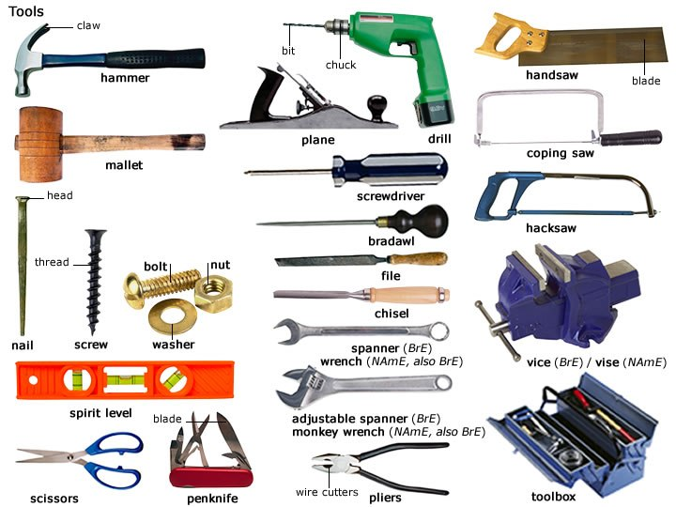

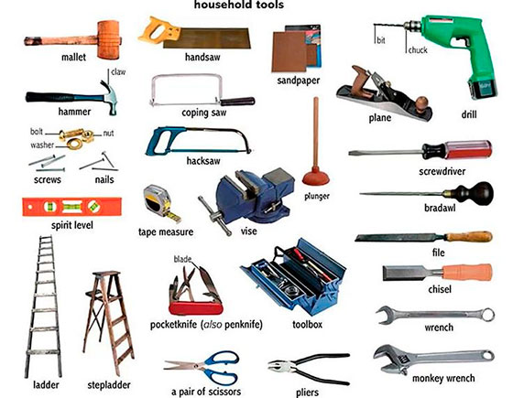
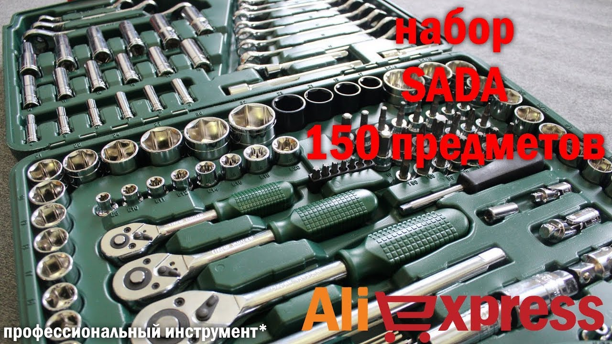

Раздел №5 Mеtals
5.1. What is the aim of this article?
5.2. How many metals are there among natural chemical elements?
5.3. How is it possible to liquefy metal?
5.4. What is a metal?
5.5. What do the metal properties depend on?
5.6. What are the main properties of metals?
5.7. What are the mostly widely used metals?
5.8. What metal is the most important?
5.9. What metals are called "noble"?
5.10. HOW is it possible to form an alloy?
5.11. What is called every constituent of an alloy? Name the constituents of bronze and brass (латунь).
5.12. What is metallurgy?
5.13. What is corrosion?
5.14. What materials are influenced by corrosion?
15. 15What materials are the most resistant to corrosion?
5.16. Why can gold and platinum be found in metallic form on
Earth?
5.17. What material is effectively immune to electrochemical corrosion under normal conditions and why?
Раздел № 6 Ecosystems
6.1. What does an ecosystem include?
6.2. What are global ecosystems?
6.3. Describe each of them in short.
6.4. What does the tropical forest contain?
6.5. What causes deforestation?
6.6 When was the term ”ecology” introduced?
6.7 What does ecology study?
6.8 What are ecosystems?
6.9 What are the differences between global and local ecosystems?
6.10What does local ecosystem include?
6.11What does the natural environment include?
6.12 What factors can create environmental problems?
6.13What does global change mean?
6.14What kind of working conditions would you prefer to have in the future?
6.15What are your aims in protecting the environment?
6.16 How important are health and safety at any workplace?
6.17What causes “global warming”?
6.18What are ecosystems?
6.19.What are the differences between global and local ecosystems?
6.20 What does local ecosystem include ?
6.21. What does the natural environment include?
6.23.What thing do you consider the most important in job advertisements?
6.24Which factors usually influence on ecosystems?

Раздел №7
7.1. What was the reaction of people after the invention of the steam engine?
7.2. Who introduced the first cheap motor car?
7.3. How did motor transport begin to spread in Europe?
7.4. When did diesel-engined lorries become general?
7.5. When and where was the first underground railway opened?
Блок В
Раздел №1 Construction Of An Automobile
1.1 Прочитайте текст, обращая внимание на сноски. Выучите слова к тексту.
1. The primary components of а car are the power plant, the power transmission, the running gear, and the control system. These constitute the chassis, оn which the body is mounted. The power plant includes the engine and its fuel, the carburetor, ignition, lubrication, and cooling systems, and the starter motor.
.2. The Engine. The greatest number of cars use piston engines. The four cycle piston engine requires four strokes of the piston per cycle. The first down stroke draws in the petrol mixture. The first upstroke compresses it. The second down stroke - the power stroke – following the combustion of the fuel, supplies the power, and the second upstroke evacuates the burned gases. Intake and exhaust valves in the cylinder control the intake of fuel and the release of burned gases. At the end of the power stroke the pressure of the burned gases in the cylinder is 2.8 to 3.5 kg/sq. cm. These gases escape with the sudden opening of the exhaust valve. They rush to а silencer (muffler), an enlarged section of piping containing expanding ducts and perforated plates through which the gases expand and are released into the atmosphere. Greater smoothness of operation of the four-cycle engine were provided bу the development of the four-cylinder engine, which supplies power from one or another of the cylinders оn each stroke of the cycle. А further increase in power and smoothness is obtained in engines of 6, 8, 12, and 16 cylinders, which are arranged in either а straight line or two banks assembled in the form of а V.
3. Carburation. Air is mixed with the vapour of the petrol in the carburetor. То prevent the air and the carburetor from becoming too cold for successful evaporation of the fuel, the air for the carburetor is usually taken from а point close to а heated part of the engine. Modern carburetors are fitted with а so-called float feed chamber and а mixing or spraying chamber. The first is а small chamber in which а small supply of petrol is maintained at а constant level. The petrol is pumped from the main tank to this chamber, the float rising as the petrol flows in until the desired level is reached, when the inlet closes. The carburetor is equipped with such devices as accelerating pumps and economizer valves, which automatically control the mixture ratio for efficient operation under varying conditions.
1.2. Notes:
running gear двигательный механизм
lubrication смазывание
intake valves впускные клапаны
exhaust valves выпускные клапаны
expanding ducts расширенные трубки
stroke of the cycle ход поршня
carburation насыщение парами бензина,
смесеобразование
evaporation испарение
float feed chamber поплавковая камера
spraying chamber камера сгорания
to pump качать (насосом)
chassis шасси
piston поршень
pressure давление
inlet впускное отверстие
to be equipped быть оснащенным
to release освобождать
1.3. Подтвердите или опровергните высказывания относительно содержания текста, исправьте неверные утверждения
(True/False/Not stated).
Предложения переведите.
1. The primary components of a car constitute the chassis on which
the body is mounted.
2. All cars use piston engines.
3. Intake and exhaust valves in the cylinder control only the intake
of fuel.
4. Modern carburetors are fitted with float feed chamber and
spraying chamber.
5. The petrol is pumped from the float feed chamber to spraying
chamber until the inlet closes.
1.4. Переведите письменно 2-й абзац текста.
1.5. Соотнесите термин с его толкованием.
1) gear a) putting a substance such as oil on something for
moving smoothly
2) lubrication b) to make liquid or gas flow somewhere continuously
3) gas c) the equipment in a vehicle that turns power from
the engine into movement
4) evaporation d) a substance in a form like air that you can’t see
or feel
5) to pump e) slowly disappearing
1.6. Прочитайте и переведите предложения.
Поставьте модальный глагол или его эквивалент в нужном
времени (Present, Past or Future).
1. The role and importance of an automobile arose from the fact
that it (can) move along roads without rails.
2. Changes in agricultural practices often (to need) to make a machine adaptable to increase its effectiveness.
3. From ancient times a man (have to) use proper equipment for
high crop production.
4. In future the automotive engineer (may) know much more than
just mechanical engineering.
5. The design engineer (must) always know enough about the
manufacturing capabilities of the supplier.
7. Прочитайте и письменно переведите предложения.
1.7. Переведите текст с русского языка на английский, используя следующие слова: power plant, power transmission, running gear, control system, carburetor, float feed chamber, spraying
chamber.Основными компонентами любого автомобиля являются двигатель, трансмиссия, ходовая часть и механизм управления. Карбюратор является составляющей частью топливной системы. Здесь
воздух смешивается с парами бензина. Современные карбюраторы
Раздел 2 Assembling A Car
2.1. Read this text.
a. First, the parts are delivered by truck or rail to the delivery area
of the car assembly plant. From here, some parts are taken to the body
shop, and other parts are transported to the chassis line. The parts are
carried around the plant by forklift trucks or conveyor belts.
b. In the body shop, the panels are welded to the frame to form the
body of the car. This is done by more than 400 robots.
с. Then the body is taken to the paint shop. Here it is cleaned
and painted by robots. Special clothing is worn by the robots to protect the paint. After this, the body is checked by human workers to
look for faults.
d. Next, the painted body moves along the conveyor belt to the
trim line and many parts are added to it. For example, the instrument
panel, the air conditioning system, the heating system and the electrical wiring are all installed here. The windscreen is inserted by robots
using laser guides.
e. Meanwhile, in the chassis line, components are added to the
chassis. First, the chassis is turned upside down, to make the work easier. Then the fuel system, the transmission, the suspension, the exhaust
system, the axles and the drive shaft are all installed. The engine is lowered into the chassis and connected to it.
f. Now the chassis and the body move simultaneously to the final
assembly line. Here the body is attached to the chassis, and all the final
parts are added. The tyres and the radiator are added here. The hoses are
connected, and the radiator and air conditioner are filled with fluid. The
car’s central computer is also installed here.
g. Lastly, the finished car and all electrical systems are tested. The
car is filled with fuel and the engine is started for the first time. The car
is put on special rollers to test the engine and the wheels. If it passes the
test, the car is finally driven out of the assembly pant.
Match the headings (1–7) with the paragraphs (a–g):
1. Trim line.
2. Paint shop.
3. Chassis line.
4. Delivery area.
5. The test.
6. Final assembly line.
7. Body shop.
Find the words in the text which mean:
1. A defect; something that detracts from perfection.
2. The base frame of a motor vehicle.
3. An automobile mechanic`s workplace.
4. The pin or spindle on which a wheel revolves.
5. A mechanical arrangement for transporting material or objects.
Complete the sentences using information from the text:
1. Some are taken to …
2. The panels are welded by …
3. Many parts are added to the painted body while it moves …
4. To install the fuel system the chassis …
5. The car is finally driven out of the assembly plant if …
Find the words in the text which are the synonyms to:
1) to set
2) to examine
3) to control
4) to attach
5) to join
2.2 Put the words in the right order to produce the correct
sentences:
1. Checked yet have the you tyres?
2. Thin are sheets why metal a welded frame to?
3. Put he the finished car on rollers does?
4. Is painted the protect to from it car rust is not body it?
5. The serviced should or in weeks battery two be now?
6. Two drills there to steel are attached arms.
7. Filled are with the bolts holes cement a.
8. Converts does the not to lower it a frequency signals.
9. Tank is very not the petrol big.
10.Can clearly the all driver around see.
2.3. Match each sentences opener (1–5) with a suitable ending (a–e):
1. When you heat it …
2. You have to soften the metal …
3. We need to bring some diggers here …
4. Hot weather makes railway lines longer …
5. The torsion forces in the storm …
a) … to deepen the trench.
b) … it does not burn or deform.
c) … and cold weather makes them shorter.
d) … must have made the bridge weaker.
e) … before you can hammer it into shape.
2.4. Match up the reports (1–5) with what the people actually
said (a–e):
1. «Ok, said the mechanic, «I’ll repair to car tomorrow».
2. «Would you like to check the engine of your car?» – asked the
chief engineer.
3. «I will not paint the damaged door of his car» – said the car
mechanic.
4. «Sorry, I haven’t examined the fuel system yet» – said the repair man.
5. «Oh, you have the oil leak under the car» – said the fuel guy to
the customer.
a) he informed
b) he admitted
c) he agreed
d) he refused
e) he offered
2.5. Replace the words underlined in each sentence (1–5) with
a word (a–e) given below:
1. This device converts the signal to a lower frequency.
2. Please send any complaints to our customer service manager.
3. My DTV card extracts the audio and video.
4. These all are displayed on my PC monitor.
5. Your MP3 player can operate with rechargeable batteries.
a) transmit
b) show
c) change
d) work
e) take out
2.6. Complete the following dialogue by choosing the missing lines
from the phrases given below.
A: … (1) ...
B: Hello. I’d like some information about your new mobile phone,
please.
A: … (2) …
B: Yes, please. Do you think you will send it by email?
A: … (3) …?
B: Yes, that’s fine.
A: … (4) …?
B: Yes, it’s.
A: … (5) …?
B: Thanks. I’ll send it today.
a. Certainly. Would you like me to send you a brochure?
b. Of cause. Shall I send it as a Word attachment?
c. Right. I’ll send it today.
d. Mobile Express. This is Customer Service, Robert speaking.
How can I help you?
e. Good. So, could I have your email address, please?
Раздел-3 The New Fuel аnd Cell Cars
3.1. Read the text.
a. The environment needs to be protected. Consumption of fossil
fuel has to fall. Emissions of greenhouse gases (carbon dioxide, nitrous
oxide, and methane) into the atmosphere must be reduced.
b. Petrol and diesel engines consume too much fossil fuel and emit
too much greenhouse gas. Hydrogen fuel cells solve this problem, but
they are usually too heavy and have low acceleration.
c. The new Hydro-X is a car with a lightweight hydrogen fuel cell.
It can accelerate quickly and cruise at high speeds of 160 km/h. It has
a range of 480 km. Its only emission is water vapour.
d. The car is based on two technologies: The hydrogen fuel cell and
the ultra-capacitor. An ultra-capacitor is a powerful capacitor which
provides enough output for fast acceleration.
e. The fuel cell in this vehicle is smaller and lighter than the ones
used in other vehicle, because it’s not needed for acceleration. As a result, the vehicle is lighter. However, it’s also more powerful because of
the ultra-capacitors.
f. The fuel cell, positioned under the floor to provide more space,
provides a maximum output of 93 kW. The motor, mounted between the
front wheels, provides high output (90 kW) and powerful torque
(276 Nm). The control unit, located over the motor, controls the electrical systems. The ultra-capacitor, set at an angle behind the rear seat to
increase luggage space, delivers immediate high-output power during
startup and acceleration, and recovers energy generated during braking.
The hydrogen storage tanks, placed under the rear seat, can be filled
with 168.3 L of compressed hydrogen gas. They’re connected to the
fuel cell by special pipes. The air pump, mounted directly on the motor,
supplies the fuel cell with oxygen.
g. There are four stages. 1. Acceleration. Power comes from both
the ultra-capacitor and the fuel cell to provide powerful acceleration.
2. Steady speed. Power comes from the fuel cell , but not from the capacitor. 3. Deceleration. The ultra-capacitor absorbs the energy released
during deceleration and stores it with power from the fuel cell.
4. Stopped. There is no power from the fuel cell. The electricity needed
to operate the air conditioner and other components is supplied by the
ultra-capacitor.
Match the headings (1–7) with the paragraphs (a–g):
1) need
2) operation
3) advantages
4) components
5) technology
6) problems
7) solution
Find the words in the text which mean:
1. The act or process of using smth.
2. An increase in speed.
3. The act of sending or throwing out.
4. A device for carrying or transporting objects or individuals.
5. To reduce the volume of smth by pressure.
Complete the sentences using information from the text:
1. We must protect …
2. The problem of petrol and diesel engine can be solved by …
3. The new Hydro-X is based on …
4. This vehicle is lighter than others because …
5. The main components of the new Hydro-X hydrogen fuels sell
car are …
Find the words in the text which are synonyms to:
1) decrease
2) decide
3) supply
4) raise
5) produce
3.2. Put the words in the right order to produce the correct sentences:
1. Today, issues, very, are, environmental, important.
2. Number, have, a, today, aeroplanes, design, of, weakness.
3. Problem, that, is, another, high, is, noise, engine.
4. Levels, must, increased, current, not , be, noise.
5. Ground, receive, data, satellite, to, relays, it, stations, and.
6. Are, which, parts, of, tested, car, the?
7. Measurements, made, the, after, test, what, are?
8. Doesn’t, when, it, a, break, bar, it, does, you, bent?
9. Use, can, how, machines, these, they?
10. Balloon, is, this, with, filled, isn’t, helium, it?
3.3. Match each sentences opener (1–5) with a suitable ending (a–e):
1. A heat pump is an electrical device that …
2. The coils are thin pipe …
3. Long ago, humans used stones …
4. The ultra-capacitor recovers the energy …
5. These steel cables are …
3.4. Choose the correct variant:
a) … able to resist tension.
b) … which is released during deceleration.
c) … which are bent in a shape many times.
d) … to make their knife blades sharper.
e) … pumps heat from one place to another.
3.5. Match up the reports (1–5) with what the people actually
said (a–e):
1. He questioned the aims.
2. He informed them about the plans maintenance team.
3. He insisted on the limits of weight.
4. He asked for a boat catalogue.
5. He told them not to transport the loads this way.
a) «Have you heard the news? A maintenance team is going out to
the platform next Monday».
b) «Are they going to inspect all machinery and check all the electrical systems?» – asked the maintenance supervisor.
c) «Don’t take these kinds of loads through the tunnel».
d) «Lorries must not be heavier than 44 tones».
e) «Hello, I’d like to order a Combo power boat».
3.6. Replace the words underlined in each sentence (1–5) with
a word (a–e) given below:
1. The car enters the pit line.
2. The driver opens the fuel flap.
3. They loosen the wheel nuts.
4. They raise the car off the ground.
5. Someone switches on the fuel pump.
a) close
b) switch off
c) put down
d) tighten
e) leave
3.7. Complete the following dialogue by choosing the missing lines
from the phrases given below:
A: … (1) …
B: Hi, Lisa. Well, I can’t open my email attachments.
A: … (2) …
B: Yes, the emails are fine. But when I double-click on the attachments, nothing happens.
68
A: … (3) …
B: Oh, right. So, what can I do?
A: … (4) …
B: No, just this.
A: … (5) …
B: OK. I’ll try that. Thanks.
a. Open Tools-Options-Security. Try lowering your security level.
b. Technical support. Lisa here. What’s the problem?
c. Well, your email program may be blocking the attachments.
d. You’re welcome.
e. OK. How about the emails themselves? Can you open them all
right?
3.8Тексты для дополнительного чтения
3.8.1. Diesel Engine
The diesel engine is a type of internal combustion engine;
more specifically, it is a compression ignition engine, in which the
fuel is ignited by being suddenly exposed to the high temperature
and pressure of a compressed gas containing oxygen (usually
atmospheric air), rather than a separate source of ignition energy
(such as a spark plug), as is the case in the gasoline engine.
This is known as the diesel cycle, after Rudolf Diesel, who
invented it in 1892 and received the patent on February 23, 1893.
Diesel intended the engine to use a variety of fuels including coal
dust. He demonstrated it in the 1900 Exposition Universelle
(World's Fair) using peanut oil. It was later refined and perfected1by Charles F. Kettering.
3.8.2 Gasoline Engine
Gasoline engine (also referred to as petrol engine or Otto engine) invented at the end of the 19th century by German engineer Nikolaus Otto is a type of internal combustion engine
which is often used for automobiles, aircraft, small mobile vehicles such as lawnmowers or motorcycles, and outboard motors for boats.The most common engine of this type is a four-stroke cycle internal combustion engine that burns gasoline (in American
English) or petrol (British English). Burning is initiated by anignition system that fires a high voltage spark through a sparkplug, in contrast to the Diesel engine which ignites the fuel through high compression. The two-stroke cycle type of engine is often used for
smaller, lighter and cheaper applications but it is less fuel efficient and, partly as a result, produces more hydrocarbon exhaust emissions. Wankel engines can also use gasoline as their fuel. One component in older engines is the carburetor, which mixes the gasoline with air. In later engines the carburetor is replaced with fuel injection. minor modifications, the gasoline engine can be made to run on other fuels. Use of natural gas, for instance, is easy, since it is already a gas and mixes readily with air; many automobiles
have been modified to run on natural gas, or to be able to switch back and forth from natural gas to gasoline. Alcohol is another fuel often used, although the fuel delivery system has to be modified to deliver a greater volume of fuel. Applications such as drag racing
where peak power output is more important than engine longetivity add nitrogen-containing fuels like nitromethane for this purpose.
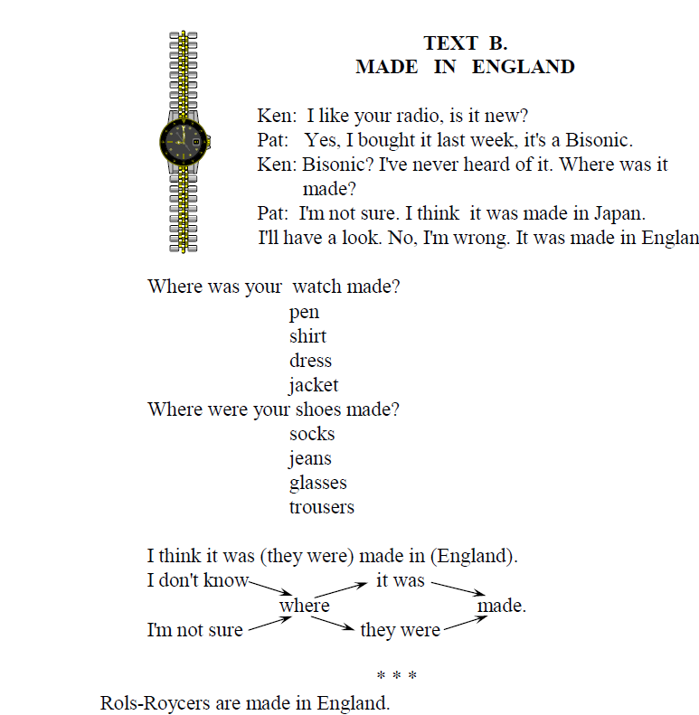

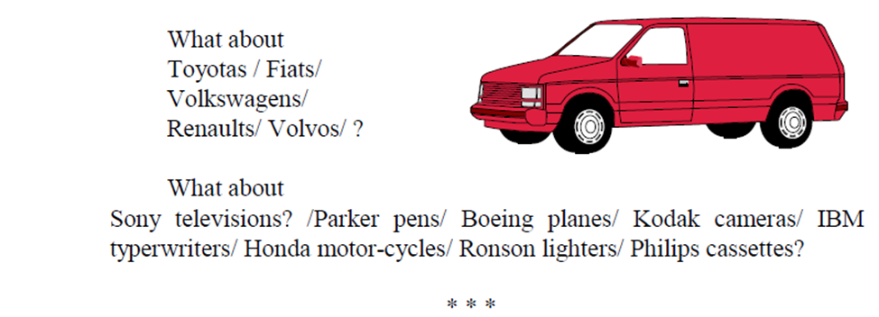
Раздел-№4 The history of tools
1. Read the text.
4.1 a. The first knives were made about two and half million years ago.
They were crafted by early ancestors of modern humans. At first sharp
pieces of stone were broken off a rock, but in later times they were
sharpened and straightened into blades.
b. The abacus is one of the first mechanical counting devices, an
ancestor of today’s computers. It consisted of a frame containing beads
on wirThe modern abacus was designed by the Chinese around the
year 1200.
c. The compass allowed sailors to navigate across oceans and discover new worlds. The compass was invented by the Chinese about
2200 years ago. A spoon-shaped piece of magnetic rock was balanced
on a flat surface. Since it was magnetic, the handle rotated to align itself
with the Earth’s magnetic poles.
d. The scythe allows people to cut grass and harvest crops from the
field. It consists of a long wooden shaft with handles on the end and in
the middle, and a long curved blade on the other end. The blade is sharp
on the inside. It was first used in Europe in the 12th century.
e. Glasses (or spectacles) make workers more productive and accurate, and allow people to work into old age. Mathematical calculations
for a spherical lens were first made by Arab scientists in the 11th century. The first spectacles were manufactured by Italian craftsmen in the
13th century.
f. The first balance scales were seen in southern Mesopotamia
about 9000 years ago. They consisted of two weighing pans attached to
either end of a beam, which was balanced on a central pivot. They allowed merchants to exact weigh of goods.
g. The chisel consists of a long, narrow, sharpened edge attached to
a handle. It’s different from the knife or axe, because it is driven by a
sharp blow from a hammer or mallet. The earliest chisels were made
from flint (a kind of stone) 10,000 years ago. Later they were used by
the Egyptians to carve stone for the pyramids.
Match the headings (1–7) with the paragraphs (a–g):
1) the spectacles
2) the chisel
3) the abacus
4) the balance scale
5) the scythe
6) the knives
7) the compass
.Find the words in the text which mean:
1. To make by hand and with much skill.
2. A state of equilibrium.
3. The flat part of a tool that has a cutting edge.
4. Long thick piece of wood or metal used in construction.
5. The axis consisting of a short shaft that supports something
that turns.
Complete the sentences using information from the text:
1. The first knives were crafted by …
2. An ancestor of modern computer is …
3. About 2200 years ago the Chinese invented …
4. The scythe consists of …
5. The first balance scales allowed …
Find the words in the text which are synonyms to:
1) pin
2) border
3) part
4) create
5) revolve
4.2 . Put the words in the right order to produce the correct
sentences:
1. The, push, into, nozzle, the, fuel, tanks.
2. Robot, stay, the, does, how, bike, the, on, upright?
3. The, is, receiver, where, wireless?
4. Helps, robot, in, the, line, strait, a, what ride?
5. Installed, yet, have, memory, you, card, the?
6. Cleaning, still, the, I, plugs, am, spark.
7. Long, antennas, had, it, hadn’t, four, it.
8. The, opened, first, bonnet, is, car, of, the.
9. Provided, is, electricity, panels, by, cells, on, solar, the.
10. Give, could, fastest, you, your, yachts, me?
4.3. Match each sentence opener (1–5) with a suitable ending (a–e):
1. You must be very pleased with …
2. The French built their high-speed link 13 years ago …
3. Eurostar trains can now travel at a …
4. The twin-bore tunnels pass under seven miles …
5. The ground under London was so hard …
a) … that we wore out six of them.
b) … the successful competition of the project.
c) … speed of up to 298 kmh.
d) … of surface railway track.
e) … and now we’ve just finished ours.:
4.4 Match up the reports (1–5) with that the people actually
said (a–e):
1. He complained about the purchase.
2. He insisted on the changes.
3. He advised the customer to complain.
4. He suggested that they discussed some problems.
5. He questioned the design.
a) «The portable TV that I Purchased at your store doesn’t work».
b) «If the goods were faulty when you bought them, complain to
the retailer».
c) «Let’s talk about some disadvantages of this design».
d) «So, what’s the problem with the design?»
e) «The design must be changed».
4.5. Replace the words underlined in each sentence (1–5) with
a word (a–e) given below:
1. Current vehicles store 50–100 sensors and this number is continually growing.
2. These sensors permit vehicles to listen and react to the environment around them.
3. Electronic sensors guarantee that new vehicles are the safest car
on the road.
4. Quick-reaction crash sensors switch on the airbags and the tension on the seatbelt.
5. Height sensors find approaching vehicles and automatically adjust the headlamps.
a) allow
b) contain
c) detect
d) activate
e) ensure
4.6. Complete the following dialogue by choosing the missing
lines from the phrases given below:
A: … (1) …
B: As you can see, they were still selling a few cars without airbags. So the Lorca, for example, had no airbag.
A: … (2) …
B: The Pamplona end the Malaga both had dual airbags. The Zamora just had one driver’s airbag.
A: … (3) …
B: Yes, generally. As you can see, we changed to a star rating with
one-star the lowest and with four-star the highest safety rating.
A: … (4) …
B: Yes, the Malaga had a four-star rating.
A: … (5) …
B: Not yet, thank you. Good bay!
a. Have you chosen any?
b. Tell me about the results for the cars 2000.
c. And did any of these cars get a four-star rating?
d. What about their safety rating? Were they better than in 1997?
e. And what about the other three?
Раздел № 5 Metals
5.1 Read the article.
The aim of the article is to discuss some characteristics of metals. One is to remember that metals are very important: out of the 92 natural chemical elements about 70 are metals.
Metal working was not the first craft known to man. Man learned to make fire and later to build furnaces in order to liquefy the metals. This liquefying process is called casting. A metal can be defined as a chemical element that possess metallic luster and which in electrolysis carries a positive charge and is liberated at the cathode. The applications of metals depend on their physical and chemical properties. It is necessary to note that metals vary in density, hardness, heat and electrical conductivity, strength, malleability, ductility and weight. The hardness of metals depends upon the presence of other substances in them and the nature of metal Itself. Everyone knows that metals are the best conductors of heat and electricity. The most widely used metals are: iron, copper, zinc, tin, lead, mercury, silver and gold. The most important metal is iron.Men used to call gold and silver "noble metals" because they fail to tarnish when exposed to the atmosphere for a long time and because they could be melted again without much loss of weight. All the other metals are called "base metals". Nowadays aluminium, magnesium and sodium are widely employed due to the development of electrochemical process for their production. Men learned to mix different metals together to form an alloy. An alloy is a metallic substance but it is not a single chemical element. It is formed by the union or mixture of two or more metals, or metals or non-metals. Probably the first alloy that was made was bronze, made of copper mixed with tin (I:10). Each constituent of an alloy is called a component. The ability of various metals to form alloys differs greatly. The craft of metal working developed into the science metallurgy. The scientists began to examine the properties of metals :their melting points, crystal structure, strength, hardness, etc. It has become possible to improve the properties of some metals and to form the new ones.
Notes
craft ремесло
malleability ковкость
ductility эластичность
single один, отдельный
loss,to loose, vпотеря,терять
used to call обычно называют
Послетекстовые упражнения
5.2.. Найдите в тексте и проанализируйте функции инфинитива.
5.3 Переведите слова, обращая внимание на суффиксы и префиксы.
metal – metallic
to liquefy – liquid – liquefaction
conduct – conductivity – conductor
nature – natural
electric – electricity
to develop – development
to differ – different – difference
to expose – exposure
to melt – melting (point)
hard – hardness
to vary – various – variet
5.4. Найдите в тексте следующие сочетания:
Характерные свойства, процесс сжижения, химический элемент, металлический блеск, нести положительный заряд, выделяться на катоде, физические и химические свойства, теплои электропроводимость, природа самого металла, электрохимический процесс, отдельный химический элемент, благородные металлы, улучшать свойства.
5.5. Переведите следующие определения. Запомните выделенные слова.
1. Density is the measurement of mass per
unit volume.
2. To tarnish means to form oxides on the surface.
3. То liquefy means to change substance into a liquid.
4. Metallurgy is the science of making metals, of mixing metals
to form alloys, of treating metals
with heat.
5. Casting is the process of melting the metals and pouring them
into the form.
5. 6. Запомните следующие синонимы. Переведите предложения. Замените подчеркнутые слова синонимичными.
to vary, to differ — отличаться, различаться
1. The metals differ in their physical and mechanical properties.
2. The metals vary greatly in density; the heaviest is osmium.
3. We must cut different metals at various speeds.
to define, to determine — определять
4. To determine the volume of a gas one must know the volume
of the vessel (сосуд) which contains it.
5. The solids obtained when two or more metals are mixed in the
molten condition and allowed to solidify can be defined аs alloys.
5.7. Запомните антонимы. Переведите.
positive — положительный
negative — отрицательный
1. Negative charge of the electron neutralizes the positive charge
of the nucleus (ядро).
2. The atom consists of a positive nucleus surrounded (окружать)
by negative charges of electricity, called electron.
hardness – softness, n
hard – твердый
soft – мягкий
1. Zinc is a hard bluish-white metal.
2. Lead is a very heavy bluish-grey metal which is very soft.
3. Chromium is so hard that will cut glass, potassium is so soft
that can be moulded like wax (воск).
5.8. Заполните пропуски соответствующими словами.
1. It is known that out of 92 ... elements about 70 are metals.
2. Man learned to build furnaces in order to ... the metals.
3. The process of liquefying the metal is called ...
4. The use of metal ... on their physical and chemical properties.
5. The ... of metals depends on the presence of other substances
in them.
6. Metals are the best ... of heat and electricity.
7. To the noble metals belong ... and ...
8. An ... is formed by the union or mixture of two or more metals.
9. The science of metal working is called ...
10. The scientists learned to ... the properties of metals.
(to depend on, metallurgy, chemical, casting, hardness, gold, alloy,
silver, to improve, to liquefy).
5.9. Найдите существительные, которые описывают свойства
металлов.
5.10. Сократите текст, сохранив его основное содержание.
5.11. Передайте содержание текста по-русски, по-английски,
сохранив последовательность подачи информации в нём.
5.12. Переведите на английский язык.
1. Чтобы изменить свойства какого-либо материала, вводят
специальные элементы или примеси.
2. Чтобы изучить распределение электронов в твердых телах,
были использованы мягкие рентгеновские лучи.
3. Для того чтобы сделать железо коррозиеустойчивым, его
можно покрыть никелем.
4. С помощью полупроводников можно превратить тепловую
энергию в электрическую.
5. Щелочные металлы хранятся в масле, чтобы исключить
влияние воздуха.
5.13. Проверьте, знаете ли вы следующие слова:
То discuss, furnace, to liquefy, casting, to define, luster, positive,
to determine, charge, negative, to vary, density, to depend on,
hard, hardness, conductivity, strength, malleability, conductor,
electricity, tin, lead, mercury, gold, silver, to tarnish, due to, alloy,
to differ, to examine, to improve, to tarnish.
5.14. Подберите эквиваленты к следующим словам:
1. furnace 1. отрицательный
2. alloy 2. свинец
3. to differ 3. улучшать
4. lead 4. олово
5. to tarnish 5. различаться
6. tin 6. сплав
7. negative 7. печь
8. luster 8. положительный
9. positive 9. твердый
10. conductor - заряд
11. density - ковкость
12. to improve 12. сжижать
13. to liquefy 13. тускнеть
14. Charge 14. блеск
15. Malleability 15. плотность
16. to vary 16. определять
17. hard 17. проводник
18. to determine 18. различаться
5.15. Прочитайте и переведите текст. Найдите инфинитив и проанализируйте его функции.
Дополнительные тексты для чтения
CORROSION
Corrosion is deterioration of useful properties in a material due to reactions with its environment. Weakening of steel due to oxidation of the iron atoms is a well-known example of electrochemical corrosion. This type of damage usually affects metallic materials, and typically produces oxide(s) and/or salt(s) of the original metal. Corrosion also includes the dissolution of ceramic materials and can refer to discolouration and weakening of polymers by the sun's ultraviolet light.
Some metals are more resistant to corrosion than others, either due to the fundamental nature of the electrochemical processes involved, or due to the details of how reaction products form. The materials most resistant to corrosion are those for which corrosion is thermodynamically unfavourable. Corrosion products of gold or platinum tend to decompose spontaneously into pure metal that is why these elements can be found in metallic
form on Earth. More common "base" metals can only be protected by more temporary means.Some metals have naturally slow reaction kinetics, eventhough their corrosion is thermodynamically favourable. These include such metals as zinc, magnesium and cadmium. While corrosion of these metals is continuous and ongoing, it happens at
an acceptably slow rate. An extreme example is graphite, which releases large amounts of energy upon oxidation but has such slow kinetics that it is effectively immune to electrochemical corrosion under normal conditions.
5.16. Найдите в тексте слова, образованные от следующих слов:
Use, oxide, metal, colour, favourable, weak, corrode.
5.17. Запомните:
Due to – из-за, вследствие, по причине
Either ... or – или … или
Раздел № 6 Ecosystems
Задание №6.1 Put true or false
1. Ecosystems are groups of plants and animals and decomposers and their
physical environment.
2. Ecosystems maybe local or global.
3. Global ecosystems are tropical rainforest , deciduous , coniferous forest, grassland,, desert.
4. Local ecosystems include lakes , rivers, ponds ,wetlands, coral, reefs, mangroves.
5.Tropical forest contains 90 percent of all living specimens.
6.The equatorial climate influence the vegetation.
7.Annual rainfall is high ,and temperatures are constant all year round.
8.This gives ideals conditions for plants growth anal helps to explain.
9.This abundant food source attract huge populations of insects, mammals and
birds.
10.There intense activity from fungi and microorganisms on the forest floor.
11.Deforestation is taking place at an alarming rate.
12. Exploitation on resources is destroying rainforest.
13. Agriculture , settlement , mineral extraction and logging cause deforestation.

Задание №6.2.

Переведите письменно профессионально-ориентированный текст:
US to end global warming study
Americans rank climate change last on a list of important issues. Only five percent of Americans say climate change is the most important issue facing the U.S. today. The issue of climate change ranks behind the lack of jobs (22%), the increasing gap
between rich and poor (18%), health care (17%), the budget deficit (13%),
immigration reform (10%), and the rising cost of education (9%).
When asked which environmental problem is most important for the current
administration to tackle, nearly 3-in-10 (29%) Americans point to air, water, and soil pollution. One-quarter (25%) of Americans say climate change is the most pressing environment problem, while a similar number (23%) identify water shortages and drought. Fewer Americans cite the shrinking of wilderness areas and animal habitats(11%) or endangered species (4%) as the most critical environmental issue.
Americans are significantly more likely to believe that people living in poorer
developing countries will be harmed by climate change than they are to say that they personally, or U.S. residents as a whole, will be negatively affected by climate
change.
6.2.1. Кратко изложите на английском языке содержание текста:
Ecology
1. The study of plants and animals in relation to their physical and biological
environment is called ecology.
2. The physical environment includes light and heat or solar radiation, moisture,
wind, oxygen, carbon dioxide, nutrients in soil, water and atmosphere.
3. The biological environment includes organisms of the same kind as well as other
plants and animals.
4. Ecology draws upon such fields as climatology, hydrology, oceanology,
oceanography, physics, chemistry, geology, and soil analysis.
5. The term “ecology” was introduced in 1866 by the German biologist Ernst Hackel.
6. Ecology is derived from the simple Greek word “oikos” meaning “a house”, “a
household”.
7. The global distribution of climate, vegetation and soil stands out similarity.
8. These three components are all closely related.
9. An ecosystem is a collection of independent parts that function as a unit and
involves inputs and outputs.
10.The major parts of an ecosystem are the producers, the consumers, the
decomposers and non-living matter.
11.The producers are green plants.
12.The consumers are herbivores and carnivores.
13.The decomposers are fungi and bacteria.
14.The non-living component consists of dead organic matter and nutrients in the soiland water.
15.The main inputs into the ecosystem are water, oxygen, carbon dioxide, nitrogen
and other elements.
16.Outputs include heat of respiration, water, nutrient losses, carbon dioxide, oxygen.
17.The plants are the primary producers because they are the first to receive sun’s
energy.
18.The planet energy is transported to animals and this forms a food web or a food
chain.
19.Ecosystems contain mineral nutrients which come from the weathering of rock.
20.Mineral nutrients are transferred by animals along food chains.

Задание № 6.3 Прочитайте текст и выполните задания.

Save Bear Island – Save us from oil addiction
Blogpost by Sune Scheller - 16 May, 2014 at 10:00 Add comment As I write this the Esperanza is sailing north along the Norwegian coast with a dedicated crew and
activists, committed to put an end to oil companies' reckless race to drill for oil in the Arctic. I am glad to be one of them.
This time we want you to join us in our journey to the far North. We need your help to spread the story of the Arctic nature reserve Bear Island and how the Norwegian state owned oil company Statoil is threatening the unique wildlife of the island with oil spills.
If you ever find yourself sailing north along the Norwegian coast you will pass by an army of offshore installations. I have only counted three wind turbines huddled
together, they are heavily outnumbered. As such the trip so far has been a stark
reminder of our addiction to fossil fuels such as coal, gas and oil.
International oil companies such as Shell and Gazprom make such a good profit from this addiction, like our society is addicted to oil these companies are addicted to money, so they have decided to begin drilling in ice filled waters risking the pristine Arctic environment and our global climate. This summer the reckless hunt for oil in the Arctic will bring two other oil companies – ExxonMobil and Statoil – to the far North. Fortunately, we will be there as well.

Задание № 6. 4. Раскройте предложенную тему на английском языке:
Ecosystems

1. Ecosystems are groups of plants and animals and decomposers and their
physical environment.
2. Ecosystems maybe local or global.
3. Global ecosystems are tropical rainforest , deciduous , coniferous forest, grassland,, desert.
4. Local ecosystems include lakes , rivers, ponds ,wetlands, coral, reefs, mangroves.
5.Tropical forest contains 90 percent of all living specimens.
6.The equatorial climate influence the vegetation.
7.Annual rainfall is high ,and temperatures are constant all year round.
8.This gives ideals conditions for plants growth anal helps to explain.
9.This abundant food source attract huge populations of insects, mammals and
birds.
10.There intense activity from fungi and microorganisms on the forest floor.
11.Deforestation is taking place at an alarming rate.
12. Exploitation on resources is destroying rainforest.
13. Agriculture , settlement , mineral extraction and logging cause deforestation.

Раздел № 7 The future public transport
7.1. Прочитайте и письменно переведите текст. Выполните задания к нему.
Different kinds of land transport
1 . What was the reaction of people after the invention of the steam engine?
In Washington the story is told of a director of the Patent Office who in the early thirties of the last century suggested that the Office was closed because "everything that could possibly be invented had been invented". People experienced a similar feeling after the invention of the steam engine. But there was a great need for a more efficient engine than the steam engine, for one without a huge boiler, an engine that could quickly be started and stopped. This problem was solved by the invention of the internal combustion engine.
2.Who introduced the first cheap motor car?
The first practical internal combustion engine was introduced in the form of a gas engine
by the German engineer N. Otto in 1876.
Since then motor transport began to spread in Europe very rapidly. But the person who
was the first to make it really popular was Henry Ford, an American manufacturer who
introduced the first cheap motor car, the famous Ford Model "T".
3. When did diesel-engined lorries become general?
The rapid development of the internal combustion engine led to its use in the farm
tractors, thereby creating a revolution in agriculture. The use of motor vehicles for carrying heavy loads developed more slowly until the 1930s when diesel-engined lorries became general. The motor cycle steadily increased in popularity as engines and tyres became more reliable and roads improved. Motor cycles were found well suited for competition races and sporting events and were also recognized as the cheapest form of fast transport.
4. When were the trams introduced first?
Buses were started in Paris in 1820. In 1828 they were introduced in London by George
Shillibeer, a coach builder who used the French name Omnibus which was obtained from the Latin word meaning "for all". His omnibuses were driven by three horses and had seats for 22 passengers. Then in the 20th century reliable petrol engines became available, and by 1912 the new motor buses were fast replacing horse-driven buses.
Trams were introduced in the middle of the 19th century. The idea was that, as the rails were smoother than the roads, less effort was needed to pull a tram than a bus. The first trams were horse-drawn but the later trams were almost all driven by electricity. The electric motor driving the tram was usually with electric current from overhead wires. Such wires are also used by trolleybuses, which run on rubber tyres and do not need rails.
Another form of transport used in London, Paris, Berlin, Moscow, St. Petersburg, Kiev and some other crowded cities is the underground railway. London's first underground railway of the "tube" type was opened in 1863, the Moscow underground in 1935.

7.2. Выучите слова к тексту.
invent – изобретать
invention – изобретение
steam engine – паровой двигатель
boiler – котел
huge – огромный
combustion – сгорание
internal – внутренний
development – развитие
vehicle – экипаж, средство передвижения
lorry – грузовик
7.3. Закончите предложения в соответствии с содержанием текста.
1. The person who was the first to make the motor transport really popular was … .
2. The rapid development of the internal combustion engine led to … .
3. The use of motor vehicles for … .
4. The electric motor driving the tram was … .
5. Another form of transport used in … .
7.5. Переведите предложения на английский язык.
1. После изобретения парового двигателя возникла необходимость в более
эффективном двигателе, чем паровой.
2. Первый двигатель внутреннего сгорания был изобретен в форме газового двигателя немецким инженером Отто в 1876 году.
3. Быстрое развитие двигателя внутреннего сгорания привело к его использованию в
тракторах.
4. Первые автобусы появились в 1820 году.
5. Еще одна форма транспорта, используемая в Лондоне, Париже, Берлине, Москве и других перенаселенных городах - это метро.
Задание Прочитайте профессионально ориентированный текст и переведите его.
7.6. Although the private ownership of cars has steadily increased as it has become more affordable, there is still a demand for public transport. The cost of a new car has fallen in real terms so that now it is cheaper than ever to own one.
Nevertheless, a minority of the population will never be in a position to do without public transport for even the shortest journey. Successive governments, under pressure from middle class car-owning voters, have poured money into the building of new roads and the widening of existing ones. Better facilities for drivers have tended to attract more drivers. The result is overcrowding on an overstretched and expensive road system. Now governments are faced with huge bills and dissatisfied voters who resent paying taxes for a poor service.
2. When people travel to other towns, the problem might eased by getting them to park on the outskirts of town. Buses could be provided to take them into the centre. These park and ride schemes are very popular and early results from large scale studies seem positive. At Southerton, for example, a council-funded scheme led to a 15 % drop in city center traffic over five months. What the council found, though, was that the measure proved somehow unpopular with shops and retail outlets in the area outside the center. Many of these places relied on passing traffic for some of their trade. As the number of people driving pastdropped, so did incomes. It was discovered that visitors found it more difficult to get around without their cars and so they were not stopping on their way into the city center. . Making car driving expensive is another way of making sure that people use public transport more. Road taxes and tolls on roads to pay for repairs tend to mean that people use their cars less. Fining drivers who are in areas wherecars have been banned can also tend to encourage them to leave their car behind.
There is one point that has to be got right for any solution to succeed. If we expect people to give up the habits of a lifetime, we must give them an alternative they can depend on. Constant delays, unannounced changes to the timetable and sudden cancellations all discourage people from using public transport. People will only use it as real option if the buses and trains are on time. Education about the treat posed to the environment by our driving culture will prove vital. As people realize that the rate of road building cannot besustained and that driving is likely to become the right of a privileged, wealthy few, so they will start to take seriously the problem of getting from A to B on public transport.
7.7. Прочитайте профессионально ориентированный текст и переведите его.
A machine
A machine is any mechanical or organic device that transmits or modifies energy to perform or assist in the performance of tasks. It normally requires an input as a trigger,and transmits the modified energy to an output, which performs the desired task. Humans have used mechanisms and machines to amplify their abilities. The primary difference between simple tools and simple mechanisms or machines is a power source and a somewhat independent operation. The term machine generally applies to an assembly of parts operating together to perform work. Generally these devices decrease the intensity of an applied force, altering the direction of the force or transforming one form of motion or energy into another. The mechanical advantage of a machine is the ratio between the resistance or load, and the force required to overcome it, although this ratio is not entirely accurate as force is required to overcome friction, as well. To compensate for this, mechanical advantage is calculated as the ratio between the distance moved by the force applied, and the distance moved by the force not applied. The mechanical efficiency of a machine is the ratio of the actual mechanical advantage (AMA) to the ideal mechanical advantage(IMA). Functioning physical machines are always less than 100% efficient. Inefficiency of a machine is the degree or percentage to which a machine does not accomplish the work it could do without the restrictions of friction. Modern power tools, automated machine tools, and human operated power machinery complicate this definition greatly. Machines used to transform heat or other energy into mechanical energy are known as engines.

Блок С

Выполнение индивидуального творческого задания:

Раздел1. Из истории автомобилестроения
Раздел 2. Виды транспортных средств
Раздел 3. Добыча нефти
Раздел 4. Альтернативные источники топлива. Защита окружающей среды.

Блок D

Экзаменационные вопросы:
(диф. зачет)

Topics

1.Assembling a Car.
2.The New Fuel Car
3.The history of tools
4.Mеtals
5.Есоsystem:

Grammar:

1.Attributive groups.
1.2Reported speech
1.3Quotation marks, complex sentences, introductory clauses
1.4Relative clauses
1.5Verbal. Infinitive: Active and Passive. Objective with the Infinitive. Nominative with the Infinitive. Infinitive phrases
1.6Gerund: Active and Passive

1.7.Participle: Form and Use. Participial Phrases: Punctuation. Absolute Constructions (Revision)

Оценивание выполнения тестов
4-балльная шкала | Показатели | Критерии
Отлично | 1. Полнота выполнения тестовых заданий;  2. Своевременность выполнения;  3. Правильность ответов на вопросы;  4. Самостоятельность тестирования;  5. и т.д. | Выполнено 85-100 % заданий предложенного теста, в заданиях открытого типа дан полный, развернутый ответ на поставленный вопрос.
Хорошо |  | Выполнено 66-84 % заданий предложенного теста, в заданиях открытого типа дан полный, развернутый ответ на поставленный вопрос; однако были допущены неточности в определении понятий, терминов и др.
Удовлетворительно |  | Выполнено 50-65 % заданий предложенного теста, в заданиях открытого типа дан неполный ответ на поставленный вопрос, в ответе не присутствуют доказательные примеры, текст со стилистическими и орфографическими ошибками.
Неудовлетворительно |  | Выполнено 0-49 % заданий предложенного теста, на поставленные вопросы ответ отсутствует или неполный, допущены существенные ошибки в теоретическом материале.

Оценивание ответа на диф. зачете
4-балльная шкала | Показатели | Критерии
Отлично | 1. Полнота изложения теоретического материала;  2. Полнота и правильность решения практического задания;  3. Правильность и/или аргументированность изложения (последовательность действий);  4. Самостоятельность ответа;  5. Культура речи;  6. и т.д. | Студент демонстрирует глубокие знания по излагаемой проблеме, делает выводы по теоретическому изложению материала, умело иллюстрирует примерами, без ошибок справляется с практическим заданием, показывает умение вести дискуссию по данной проблеме, выполняется коммуникативная задача, логичность и связанность высказывания.
Хорошо |  | Студент освещает основные аспекты данной проблемы, делает выводы, хорошо справляется с практическим заданием, реагирует на вопросы преподавателя, провоцирующие дискуссию, решает коммуникативную задачу высказывания, допускает 1-2 лексико-грамматические ошибки.
Удовлетворительно |  | Студент недостаточно полно освещает теоретические вопросы, делает некоторые ошибки при выполнении практического задания, не может продемонстрировать умения вести дискуссию, нарушается логичность и связанность высказывания. Допускает 4-5 лексико-грамматических и фонетических ошибок в устном сообщении, искажающие смысл высказывания.
Неудовлетворительно |  | Студент недостаточно полно освещает теоретические вопросы, не может справиться с практическим заданием, не может дать правильный ответ на дополнительный вопрос, отсутствие логичности и связанность высказывания. Допускает грубые лексико-грамматические и фонетические ошибки в устном сообщении, искажающие смысл высказывания.

Раздел 3. Методические материалы, определяющие процедуры оценивания знаний, умений, навыков и опыта деятельности, характеризующих этапы формирования компетенций

Основными этапами формирования компетенций по дисциплине при изучении студентами дисциплины являются последовательное изучение содержательно связанных между собой разделов.
Оценка «отлично» ставится, если студент демонстрирует глубокие знания по излагаемой проблеме; грамматически точно использует лексический материал и речевые структуры; аргументировано высказывается по заданной теме; если он при соблюдении вышеуказанных критериев допустил отдельные неточности, не нарушающие процесс коммуникации; и делает выводы по теоретическому изложению материала, умело иллюстрирует примерами, без ошибок справляется с практическим заданием, показывает умение вести дискуссию по данной проблеме.
Оценка «хорошо» ставится, если студент умеет грамматически точно, используя лексику и речевые структуры, логично высказаться по заданной теме; при соблюдении вышеуказанных критериев допускает неточности, не нарушающие процесс коммуникации; освещает основные аспекты данной проблемы, делает выводы, хорошо справляется с практическим заданием, реагирует на вопросы преподавателя, провоцирующие научную дискуссию, решает коммуникативную задачу высказывания.
Оценка «удовлетворительно» ставится, если студент показывает недостаточное владение языком, высказывается по заданной теме при допуске языковых неточностей; недостаточно полно освещает теоретические вопросы, делает некоторые ошибки при выполнении практического задания, не может продемонстрировать умения вести дискуссию.
Оценка «неудовлетворительно» ставится, если студент недостаточно полно освещает теоретические вопросы, не может справиться с практическим заданием, не может дать правильный ответ на дополнительный вопрос, допускает ошибки в устном сообщении по теме.
При оценивании результатов обучения: знания, умения, навыки и опыта деятельности (владения) в процессе формирования заявленных компетенций используются различные формы оценочных средств текущего, рубежного и итогового контроля (промежуточной аттестации).

Рекомендации к компонентному составу оценочных материалов
Формы контроля | Виды контроля | Состав оценочных материалов
 |  | Для обучающегося | Для экзаменатора
Текущий контроль - контроль самостоятельной работы студентов | Тестирование | Бланк с тестовыми заданиями (в случае бланковой формы тестирования) и инструкция по заполнению.  Доступ к тесту в системе компьютерного тестирования и инструкции по работе в  системе. | Банк тестовых заданий  Инструкция по обработке результатов
 | Устное собеседование  (учебно-речевая ситуация) | Вопросы для собеседования и перечень дискуссионных тем представлены в методических указаниях к практическим занятиям (семинарским) | Критерии оценивания представлены в методических указаниях по освоению дисциплины

Оценочные средства | Критерий для оценки «5» | Критерий для оценки «4» | Критерий для оценки «3» | Критерий для оценки «2»
Задания блока А.0 | Процент правильных ответов составляет 85% и более | Процент правильных ответов составляет от 66% до 84% | Процент правильных ответов составляет от 50% до 65% | Процент правильных ответов составляет менее 50%
Задания блока А.1 | продемонстрировано глубокое знание по теме практического занятия, полно излагает материал, продемонстрировано отличное владение терминологией, проявлено умение убеждать с использованием логичных доводов,  приводит необходимые примеры не только из учебной литературы, но и самостоятельно составленные | формулирует полный правильный ответ на вопросы практического занятия с соблюдением логики изложения материала, но допускает при ответе  отдельные неточности, не имеющие принципиального характера, недостаточно четко и полно отвечает на уточняющие и дополнительные вопросы | продемонстрировал неполные знания, допускает ошибки и неточности при ответе на вопросы практического занятия, продемонстрировал неумение логически выстроить материал ответа и формулировать свою позицию по проблемным вопросам | не способен сформулировать ответ по вопросам практического занятия (семинара); дает неверные, содержащие фактические ошибки ответы на вопросы практического занятия (семинара); не способен ответить на дополнительные и уточняющие вопросы.  Неудовлетворительная оценка выставляется в случае отказа отвечать на  вопросы практического занятия
Задания блока Б | демонстрирует полный и правильный ответ, изложенный в определенной логической последовательности; если студент свободно оперирует лингвистическими законами; анализирует языковые и правовые явления, используя различные источники информации; делает творчески обоснованные выводы. Допускается одна-две несущественные ошибки | демонстрирует полный и правильный ответ, изложенный в определенной логической последовательности; если студент умеет оперировать лингвистическими законами; анализирует языковые и правовые явления; делает обоснованные выводы. Допускаются одна-две ошибки | демонстрирует частично правильный и неполный ответ; нарушена логика ответа; если студент знает лингвистические законы, но оперирует ими слабо | ответы односложные «да», «нет»; аргументация отсутствует либо ошибочны ее основные положения; большинство важных фактов отсутствует, выводы не делаются.
Задания блока С | Задания выполнены полностью, в представленном решении обоснованно получен правильный ответ | задания выполнены полностью, но нет достаточного обоснования или при верном решении допущена ошибка, не влияющая на правильную последовательность рассуждений, и, возможно, приведшая к неверному ответу | задания выполнены частично, нет достаточного обоснования или при выполнении допущены ошибки, влияющие на правильную последовательность рассуждений, и, приведшие к неверному ответу | задания не выполнены или выполнены неверно.
Задания блока D | отвечает полно, излагает изученный материал, даёт правильные определения языковых понятий; обнаруживает понимание материала, способен обосновать свои суждения, применить знания на практике, привести необходимые примеры не только по учебнику, но и самостоятельно составленные; излагает материал последовательно и правильно с точки зрения норм литературного языка. | даёт ответ, удовлетворяющий тем же требованиям, что и для отметки «5», но допускает 1-2 ошибки, которые сам же и исправляет, и 1-2 недочёта при речевом оформлении ответа. | обучающийся обнаруживает знание и понимание основных положений вопроса, но излагает материал неполно и допускает неточности в определении языковых понятий или формулировке правил; не умеет обосновать свои суждения и привести собственные примеры; излагает материал непоследовательно и допускает ошибки в речевом оформлении ответа. | ставится, если студент обнаруживает незнание большей части материала вопроса, допускает ошибки в формулировке определений и правил беспорядочно и неуверенно излагает материал.

